TIPS FOR MAINTAINING ENERGY EFFICIENCY
[Organization Name] – [Facility Name]
Boilers, steam/hot water systems
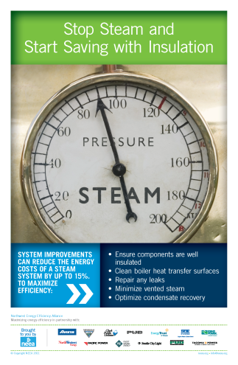
- Train personnel. Allow only well-trained, qualified personnel to run, adjust, inspect and maintain boiler systems. Investigate training options in your area at: http://neea.org/participate/calendar.aspx
- Control excess combustion air. Too little air results in incomplete combustion, while too much air wastes energy as the excess air is heated to the stack temperature. Available controls range from simple, low-cost on-off control to more expensive automatic oxygen trim control; the choice of control depends on the burner size. The burner should be adjusted only by qualified personnel, so work with a supplier to correct the air-fuel mixture.
- Keep the boiler clean. Fouling of the fireside of the boiler tubes by deposits from burning fuel (especially solid fuels) can dramatically reduce heat transfer. Also, mineral deposits or “scale” on the waterside of the boiler tubes reduce efficiency. Test boiler water daily in small low-pressure boilers and hourly in large high-pressure boilers. If flue gas temperatures are too high, clean the system and adjust the water chemistry and the air-fuel mixture. Also, although using blowdown water can prevent scale from forming, it takes a great deal of energy so use automatic blowdown controls to ensure minimal use.
- Minimize boiler short-cycling losses. An oversized boiler turns on and off more often than a boiler properly matched to the demand because it uses extra energy to heat up again each time.
- Improve boiler insulation. Reduce heat loss through radiation and convection by adding insulation directly to the outer walls of the boiler. Removable insulation pads will not interfere with maintenance.
- Reduce leaks. Steam leaks can often go undetected in underground distribution pipes. Monitor blowdown and feedwater to detect such leaks and make necessary repairs immediately
- Insulate. A great deal of heat energy can be lost through the piping distribution system. Adding 2.5 cm (1 in.) of insulation can reduce heat loss by 80 to 90 percent. Removable insulation pads can cover areas requiring maintenance.
- Remove unused piping. Remove any older, redundant piping and isolate steam from unused lines.
- Ensure proper pipe sizing. If the pipes have too small a diameter for the flow rate, the pressure drop along the pipe may result in too little pressure or too low a flow rate for the end use.
- Check and repair steam traps. Steam traps—an essential part of many steam distribution systems—fail at the rate of approximately 25 percent a year. Steam traps must also be the right size. Undersized traps can result in condensate backup and excessive cycling. The failure of oversized traps can lose large quantities of steam. In general, check a high-pressure system weekly or monthly and a low-pressure system annually.
- Assess end-use needs regularly. Boilers often provide hot water or steam at temperatures and pressures far beyond actual needs.

Compressed Air Systems
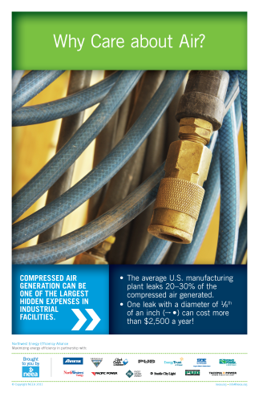
- Do a Compressed Air Audit. “How?” and “Why?” questions can uncover wasteful practices, poor usage and unsafe operation. Reduce the use of compressed air as much as possible. Review usage periodically to make sure no inappropriate new applications have begun.
- Find and fix leaks. Leaks and pressure drops create losses and reducing these losses often results in significant savings. Here are some simple examples of the kinds of leaks and the financial impact when electricity costs just $.05/kWh:
∙ A $100/year leak cannot be felt or heard
∙ A $400/year leak can be felt but not heard
∙ A $700/year leak can be felt and heard
Regularly use handheld leak detection devices to find leaks efficiently. When you find a leak, mark it with a tag. Write on the tag the date, system pressure, size of the leak, system fluid, location (such as “at the gasket,” “on the run of a tee,” etc.) and how much the leak is costing. This encourages fixing the bigger leaks rapidly.
- Examine the air dryer. Air drying equipment can use as much as 20 percent of the total system power, so make sure it is maintained as required.
- Repair or replace condensate drains. To have high-quality compressed air, you must remove condensate collected by coolers, dryers, receivers and filters. Inspect the drains regularly to prevent large amounts of air from being wasted by:
∙ Manual drains that are always “cracked” slightly open
∙ Float drains that have failed in the open position
∙ Timer drains set to drain excessively
- Replace or upgrade filters. Because dirty filters can require an increase in compressor pressure, monitoring and replacing these filters regularly can reduce the cost of operating the system. To maintain higher system efficiency, upgrade and replace filters with low-differential filters or with an oversized filtration system.
- Follow a systematic inspection and maintenance schedule. Focus on filters, oilers, quick couple points and all other maintenance points as set out by the equipment supplier.

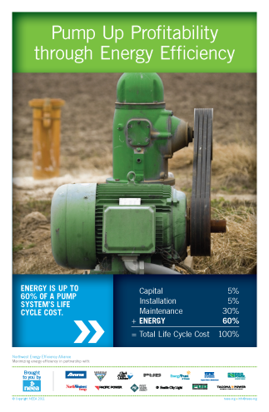
Pumps
- Lubricate regularly using high-quality lubricants. Wear is a significant cause of decreased efficiency in liquid pumps. Lubricate bearings and maintain the shaft seals.
- Regularly reset wear ring clearances and smooth the impeller and casing waterways. Pump wear ring clearances can have a major influence on efficiency.
- Develop and implement a proper maintenance schedule based on the manufacturer's recommendations.

Electric Motors
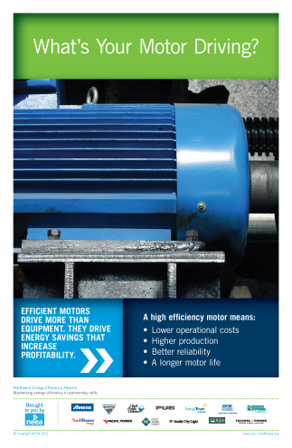
- Inspect and replace belts. Check the belt tension: if it's too loose, the belt can slip and waste energy; if it's too tight, the belt can cause excessive wear on the motor and bearings. A recent study has shown that replacing V-belts with cogged V-belts can reduce energy consumption by 0.4 to 10.0 percent, with a typical payback period of one to five months.
- Lubricate regularly using high-quality lubricants. Premium lubricants have been shown to provide energy savings of 3 to 20 percent in gear reducers, compressors and motors. They can also extend the life of your motor system by improving resistance to deterioration.
- Check the quality of your power. Incorrect voltages or phase balances, current leaks and harmonics in the electrical supply can all reduce motor reliability and efficiency. Studies have estimated that improvements to electric supply systems can result in savings of 1 to 5 percent in motor loads, along with improved reliability and extended motor life.
- Predictive maintenance. By making small investments in regular maintenance of a motor, you can maintain its efficiency and postpone failure, resulting in substantial savings. Use modern infrared optical sensors and vibration sensors to predict a failure. Combining this with a good record-keeping system is likely to result in less downtime.

Refrigerators
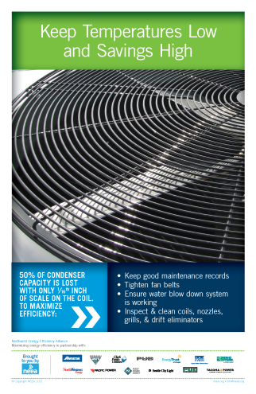
- Check the operating temperature of the room regularly and adjust thermostats as needed.
- Clean the cooling coils. Be sure to perform this several times a year, and make sure that the condensation drain is not blocked.
- Shade outdoor cooling coils from the sun.
- Check the air circulation. Make sure that air can move freely around the heat exchange coils, both inside the room (evaporator) and outside (air-cooled condenser). A restricted flow of cooling air reduces the life of the compressor and requires more energy to operate.
- Check and repair door latches and seals. Ensure the refrigerated space is airtight. Also, verify that users close the door immediately and completely after every access.

